import pandas as pd

import matplotlib.pyplot as plt

import seaborn as sns

import re

import numpy as np

from sklearn import tree

from sklearn.model_selection import train_test_split

%matplotlib inline

sns.set()

test_df = pd.read_csv('/content/titanic-test.csv')

train_df = pd.read_csv('/content/titanic-train.csv')

train_df.head()

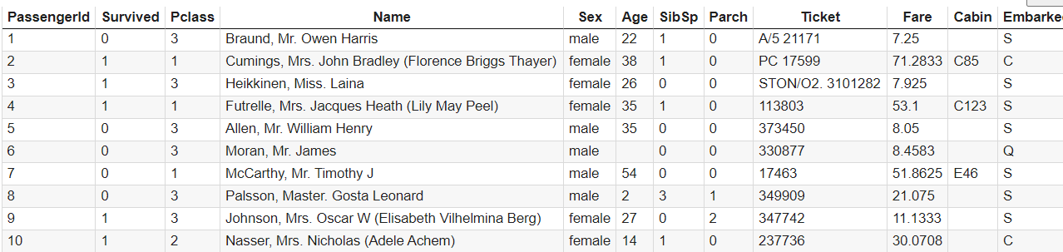

train_df.info()

train_df.Sex.value_counts().plot(kind = 'bar', color = ['b', 'r'])

plt.title('Distribucion x sexo')

plt.show()

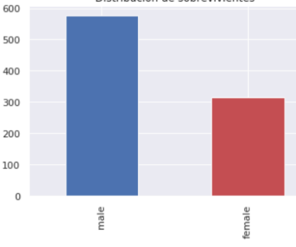

#Esta seria otra forma de filtrar los sobrevivientes y separarlos por sexo

df_train[ df_train['Survived'] == 1 ]['Sex'].value_counts().plot(kind='bar', color=['b','r'])

plt.title('Distribucion de sobrevivientes')

Separar mujeres / hombers

men=train_df.loc[train_df['Sex']=='male']

women=train_df.loc[train_df['Sex']=='female']

men.Survived.value_counts().plot(kind='bar', color=['b','r'])

plt.title('Distribucion de hombre sobrevivientes')

plt.show()

women.Survived.value_counts().plot(kind='bar', color=['b','r'])

plt.title('Distribucion de mujeres sobrevivientes')

plt.show()

train_df['Age'] = train_df['Age'].fillna(train_df['Age'].median())

train_df['Embarked'] = train_df['Embarked'].fillna('S')

train_predictors = train_df.drop(['PassengerId', 'Survived', 'Name', 'Ticket', 'Cabin'], axis = 1)

categorical_cols = [cname for cname in train_predictors.columns if

                        train_predictors[cname].nunique() < 10 and

                        train_predictors[cname].dtype == 'object'

numerical_cols = [cname for cname in train_predictors.columns if

                   train_predictors[cname].dtype in ['int64', 'float64']

                 ]

my_cols = categorical_cols + numerical_cols

train_predictors = train_predictors[my_cols]

dummy_encoded_train_predictors = pd.get_dummies(train_predictors)

train_df['Pclass'].value_counts()

3 491

1 216

2 184

Name: Pclass, dtype: int64

y_target = train_df['Survived'].values

x_features_one = dummy_encoded_train_predictors.values

x_train, x_validation, y_train, y_validation = train_test_split(x_features_one, y_target, test_size = .25, random_state = 1)

tree_one = tree.DecisionTreeClassifier()

tree_one = tree_one.fit(x_features_one, y_target)

tree_one_accuracy = round(tree_one.score(x_features_one, y_target), 4)

print('Accuracy: %0.4f' % (tree_one_accuracy))

Accuracy: 0.9798

from io import StringIO

from IPython.display import Image, display

import pydotplus

out = StringIO()

tree.export_graphviz(tree_one, out_file = out)

graph = pydotplus.graph_from_dot_data(out.getvalue())

graph.write_png('titanic.png')

True